# Using Law of Cosines to Solve Oblique Triangles

Although the Law of Sines is useful in solving certain oblique triangles (ASA, AAS, and SSA), it does not help us when trying to solve other types of oblique triangles, such as SAS (side-angle-side) or SSS (side-side-side).

The **Law of Cosines** states that the square of any side of a triangle is equal to the sum of the squares of the other two sides minus twice the product of the other two sides and the cosine of the included angle. For triangles labeled as shown below

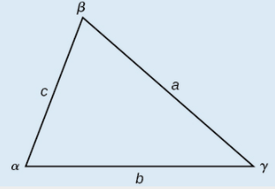

With angles $α$, $β$, and $γ$, and opposite corresponding sides $a$, $b$, and $c$, respectively, the Law of Cosines is given as three equations:

$$a^{2}=b^{2}+c^{2}-2bc\cos{α}$$

$$b^{2}=a^{2}+c^{2}-2ac\cos{β}$$

$$c^{2}=a^{2}+b^{2}-2ab\cos{γ}$$

To solve for a missing side measurement, the corresponding opposite angle measure is needed.

Given two sides and the angle between them (SAS), find the measures of the remaining side and angles of a triangle.

1. Sketch the triangle. Identify the measures of the known sides and angles. Use variables to represent the measures of the unknown sides and angles.

2. Apply the Law of Cosines to find the length of the unknown side or angle.

3. Apply the Law of Sines or Cosines to find the measure of a second angle.

4. Compute the measure of the remaining angle.

Examples

1. Find the unknown side and angles of the triangle shown below.

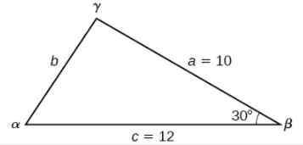

1. Find the angle $α$ for the given triangle if side $a=20$, side $b=25$, and side $c=18$.

# Solving Applied Problems Using the Law of Cosines

Just like with the Law of Sines, we can apply the Law of Cosines when solving problems with oblique triangles.

Examples

1. On many cell phones with GPS, an approximate location can be given before the GPS signal is received. This is accomplished through a process called triangulation, which works by using the distances from two known points. Suppose there are two cell phone towers within range of a cell phone. The two towers are located $6000$ feet apart along a straight highway, running east to west, and the cell phone is north of the highway. Based on the signal delay, it can be determined that the signal is $5,050$ feet from the first tower and $2,420$ feet from the second tower. Determine the position of the cell phone north and east of the first tower and determine how far it is from the highway.
2. Suppose a boat leaves port, travels $10$ miles, turns $20$ degrees, and travels another $8$ miles. How far from port is the boat? Use the diagram below.

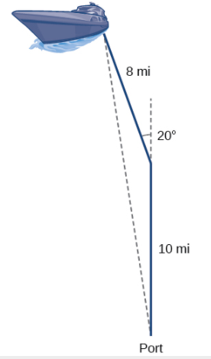

# Using Heron’s Formula to Find the Area of a Triangle

If we know three sides of a triangle, we can find the area without having to find the height of the triangle. Heron of Alexandria was a geometer who lived during the first century A.D. He discovered a formula for finding the area of oblique triangles when three sides are known.

**Heron’s formula** finds the area of oblique triangles in which sides $a$, $b$, and $c$ are known.

$$\text{Area}=\sqrt{s\left(s-a\right)\left(s-b\right)\left(s-c\right)}$$

Where $s=\frac{(a+b+c)}{2}$ is one half of the perimeter of the triangle, sometimes called the semi-perimeter.

Examples

1. Use Heron’s formula to find the area of a triangle with sides of lengths $a=29.7$ ft, $b=42.3$ ft, and $c=38.4$ ft.
2. A Chicago city developer wants to construct a building consisting of artist’s lofts on a triangular lot bordered by Rush Street, Wabash Avenue, and Pearson Street. The frontage along Rush Street is approximately $62.4$ meters, along Wabash Avenue it is approximately $43.5$ meters, and along Pearson Street it is approximately $34.1$ meters. How many square meters are available to the developer? Use the diagram below.

